EECS 349&444 (Fall 2019) – HW2


Case Western Reserve University Department of Computer and Data Sciences

EECS 349&444: Computer Security

Assignment Date: | 10/17/2019
Sumission Date: | 10/23/2019@11:59pm
First Name: | AMAN
Last Name: | ANAND
Google Drive Link:

Abstract of the feedback:

EECS 349&444 (Fall 2019) – HW2

Q1: Assembly code is shown below. Please access its functionality and rewrite in C to printf()

its output. (10pts)

push mov and sub call mov mov mov mov imul mov mov mov shr add sar sub mov mov mov mov mov call mov leave retn

ebp

ebp, esp

esp, 0FFFFFFF0h

esp, 20h

___main // Main segment is started here

dword ptr [esp+1Ch], 3 // Double word i.e. 32 bits. 3 is stored in esp+1Ch location

dword ptr [esp+18h], 5 // Double word i.e. 32 bits. 5 is stored in esp+1Ch location

dword ptr [esp+14h], 0 // Double word i.e. 32 bits. 0 is stored in esp+1Ch location

eax, [esp+1Ch] // store 3 in eax

eax, [esp+18h] // Signed multiply eax with 5

edx, eax // move the result into edx
H.
eax, [esp+1Ch] // move 3 into eax again

ecx, eax // move 3 into ecx now

ecx, 1Fh // shift right ecx 31 bits , hence the MSB is now retained and rest bits are shifted

eax, ecx // add eax and ecx and store in eax

eax, 1 // shift arithmatic right by 1 value for eax i.e. retain the MSB for 1 unit and shift

edx, eax // subtract eax from edx and store in edx

eax, edx // move edx value into eax

[esp+14h], eax // final movement between registers before printing result

eax, [esp+14h]

[esp+4], eax

dword ptr [esp], offset aD ; "%d" // Result is printed out for the operation in a decimal format

_printf

eax, 0

_main endp

Functionality of Code:

To put it simply the code tries to perform the following operation and if the explanation is followed step by step above we get the desired result as, Result = (3 * 5 ) – sar ((3 + shr(3,by 31 bits))
Hence it translates to , Result = (3*5) – ((3+0))/2; Result for question is 14 in decimal.

EECS 349&444 (Fall 2019) – HW2

Q2: Assembly code is shown below. Please access its functionality and rewrite in C to printf()

its output. (15pts)
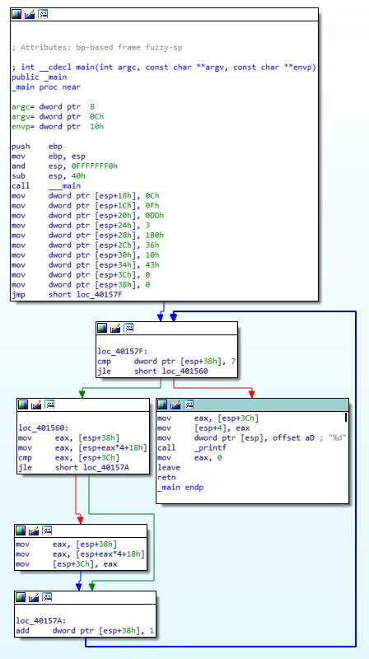

← Part of the code which initializes values into the 32 bit double word and stores them at various memory locations as denoted in the main function.

← Compares the value stored in dword ptr [esp+38h] location with 7 and goes to specified location if the value is less than or equal to 7. Hence the code runs from the value going from 0 to 7.

→Eax is loaded with esp+38h. Then eax is loaded with esp+eax*4 +18h hence the next address. And then compared with the value stored in esp+3Ch essentially comparing all variables with value in esp+3Ch

← Finally when the esp+38h location value is greater than 7. The value stored in esp+3Ch is moved to eax and then displayed as a decimal number using printf.

If the condition is False, then move the value of esp+eax*3+38h into esp+3Ch. This way the highest value of all the numbers is tored in esp+3Ch

- If eax is less than or equal to esp+3Ch jump to this segment and increment the value in esp+38h by one and go back to the beginning of loop.

EECS 349&444 (Fall 2019) – HW2

Functionality of the above code:

The above code takes an array of numbers stored in memory locations and then we go through all the values and compare them such that the largest value out of the set of arguments is stored in the esp+3Ch location and finally the highest value among the set of inputs is printed as a decimal number. The largest number is 1B0 which is 432 in decimal.

Q3: Assembly code is shown below. Please access its functionality and rewrite in C to printf()

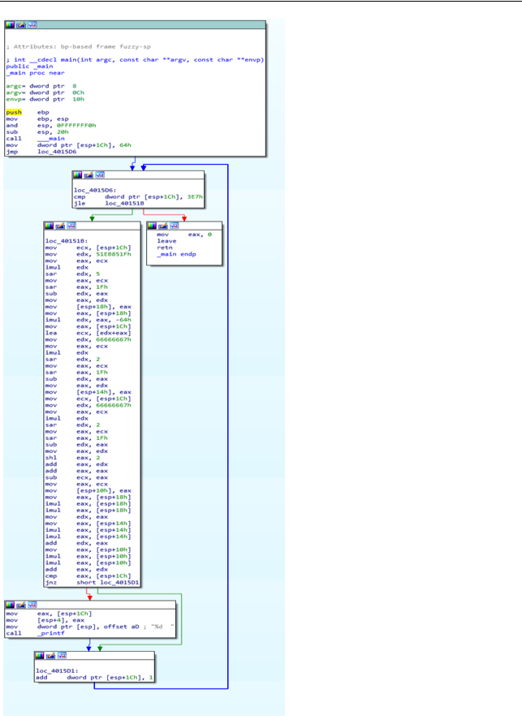

This segment of the code uses obfuscation techniques to hide the true nature of the code which is to go on comparing at the end of these sequence the value stored in esp+1Ch with a large value which always results in false leading to printing the values from 100 to 999 as outputs.

Functionality of above Given code:
The given code starts from the initial count of 100 and goes on up to 999 with the aid of obfuscation in order to hide its actual functionality which is to go ahead calculating and printing the value stored in the esp+1Ch and then incrementing it by 1 each time essentially printing all the numbers from 100 to 999.

Q4: Given a binary (i.e., HW2-P3-Q4), please use IDA to access its functionality and rewrite in C to printf() its output. (20pts)

The file is read using IDA and the following is observed :

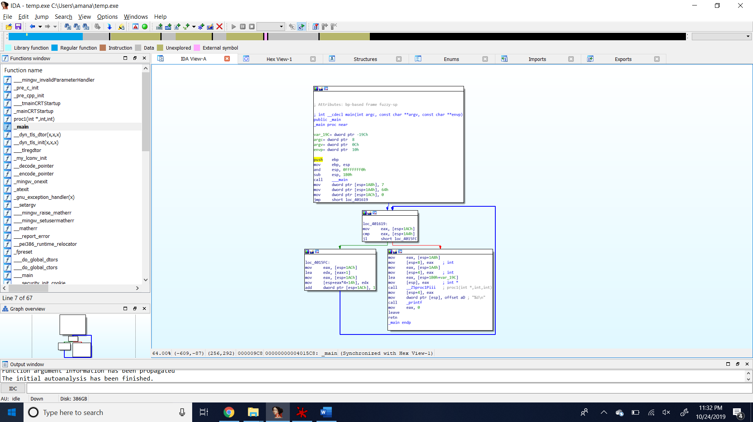

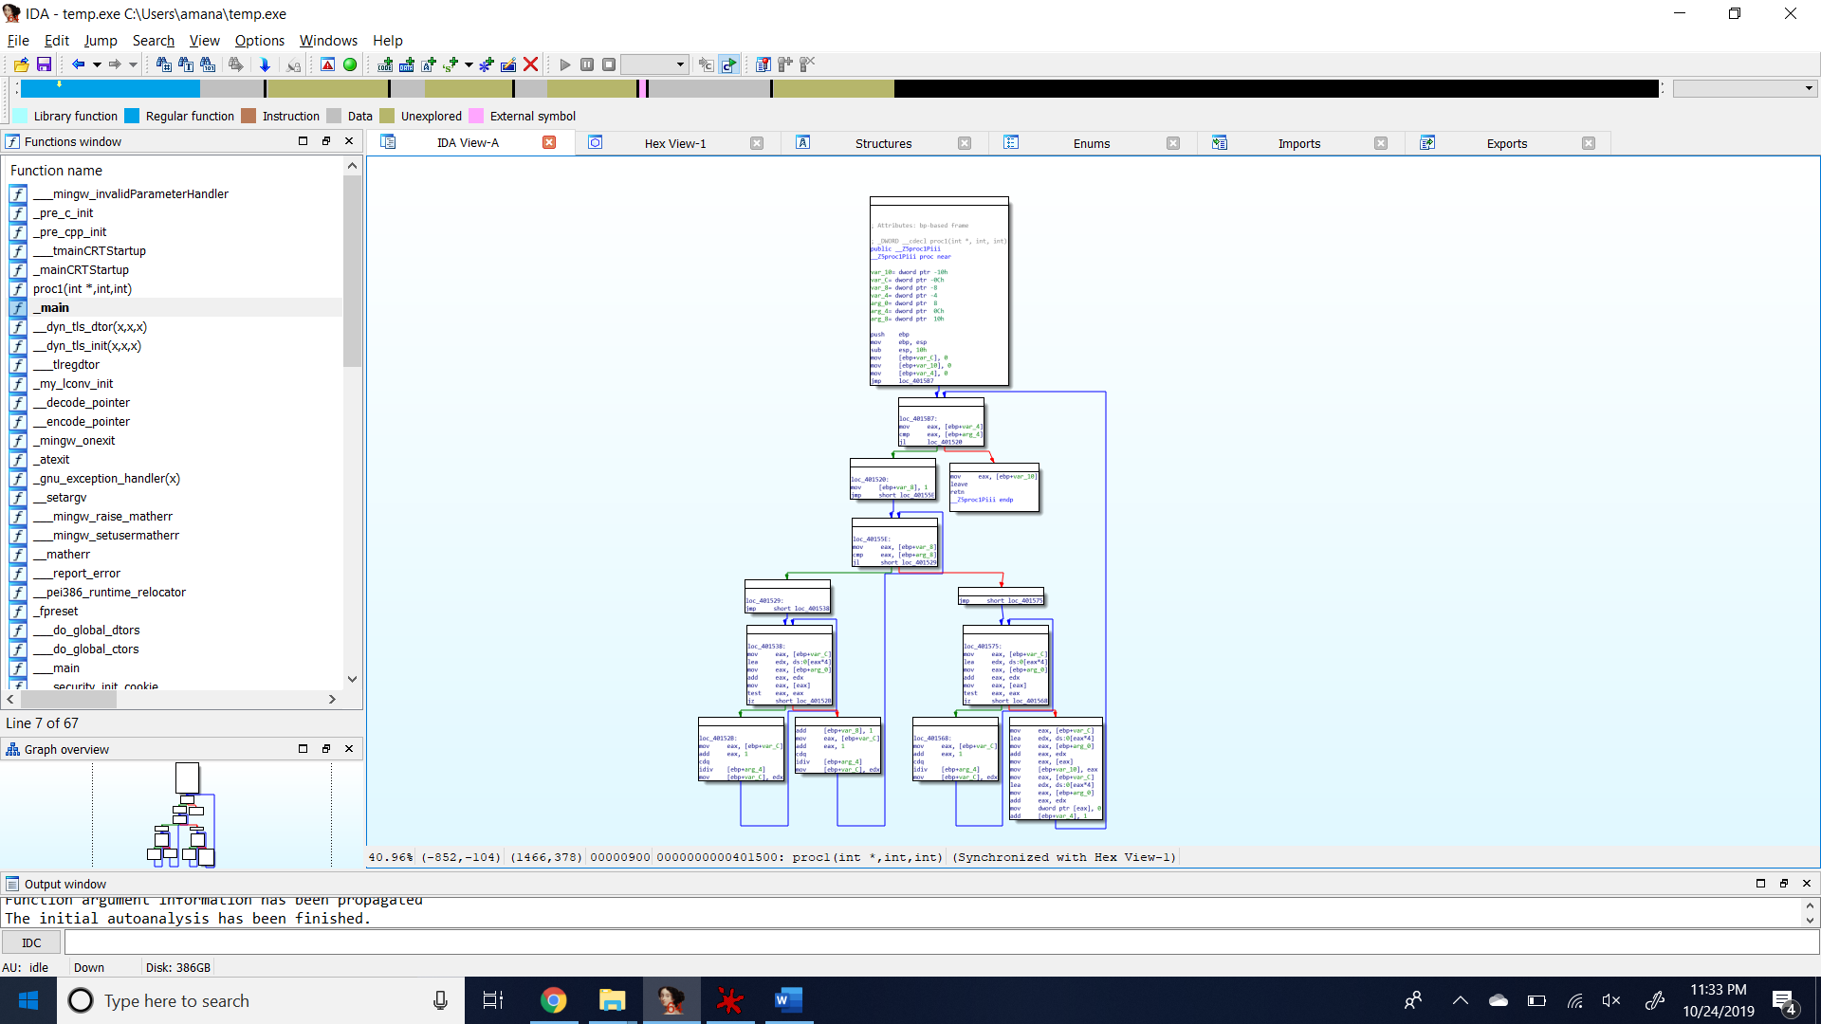

Functionality of code :

The code makes use of the main code segment and the function called. The main code segment creates a memory storage of 64h bits i.e. 100 locations. Then the function is called which is used to go on implementing the following equation , y[x+1]=(y[x]+7)%x; where x ranges from 1 to 100 locations and finally we are printing the value stored in y[100]=50. Hence finally 50 is being printed as the output for the given program.

